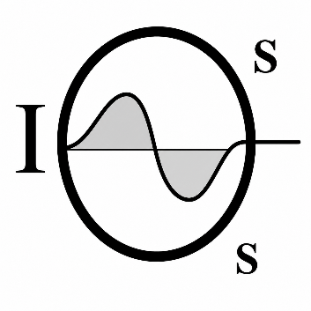  INSPECTION & SPECIFICATION SERVICES CC. | CONTROLLED ENGINEERING INSPECTION REPORT  CABLE BELT LOWER ANGLE STATION SHEAVES  Inspection & Specification Services cc.  Reg. No. 1990/020258/23  24 Jonkershoek Street, Vaalpark, 1947  Office: +27 (016) 971-2259  Cell: +27 (083) 442-7913  Email: iss@inspecserv.co.za.
MECHANICAL ASSET CONDITION ASSESSMENT
Cable Belt Lower Angle Station Sheaves Inspection Report
Inspection report · engineering assessment · maintenance recommendations
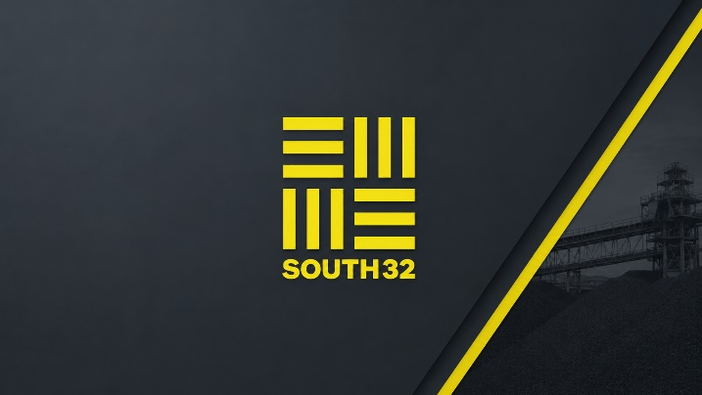 | 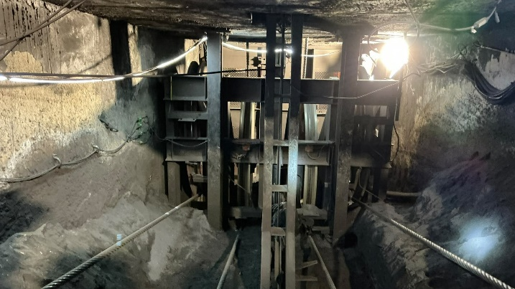

Client | South32 | Mine / site | Wessels Mine
Area / system | Cable Belt - Lower Angle Station | Asset / asset group | Lower Angle Station Sheaves 1-4
Report number | ISS_IRS32-Wessels-200726 | Revision | 1.1
Issue date | 17/08/2026 | Inspection date | 20 July 2026
Issue status | Approved | Prepared by | Brendan Wood
Reviewed by | Kevin Wood | Approved by | Kevin Wood
Client reference | South32 Wessels | ISS job number | IRS32-Wessels-200726
CONFIDENTIALITY & RELIANCE
Prepared for the named client and stated purpose only. Reliance, distribution and operational decisions remain subject to the agreed scope, contractual requirements, stated limitations and responsible engineering review.
Inspection & Specification Services cc. · Reg. No. 1990/020258/23 · 24 Jonkershoek Street, Vaalpark, 1947
Office: +27 (016) 971-2259 · Cell: +27 (083) 442-7913 · iss@inspecserv.co.za

